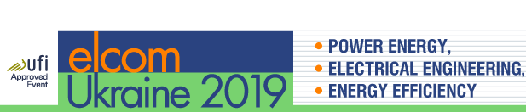
When: Tuesday, 9 April, 2019 to Friday, 12 April, 2019
Where: KyivExpoPlaza Exhibition Center

23rd International Trade Fair for power energy, electrical engineering, radio electronic components, industrial automation and lighting equipment
Exhibited products and services:
Power engineering:
- High-voltage equipment (Switching equipment; switchboards; transformer substations;
- Low-voltage equipment (energy installation; switchboard; switching equipment; Equipment and tools)
- Energy saving (Energy saving technologies; Energy saving systems, Occupational safety and health)
Energy supply and electrical power systems
- Cogeneration plants
- Power plants.
- Stabilizers, converters.
- Inverters, rectifiers, batteries.
- UPS.
- Switchboard equipment.
- Power supply systems.
- Actuators and transducers.
- Grounding and lightning protection systems.
Cabling and wiring products
- Cables.
- Wires.
- Cabling systems.
- Electrical products.
- Equipment installation and wiring.
Lighting engineering
- Technical lighting (Street lighting, Road lighting, Lighting of industrial plants and buildings, Lighting systems for offices and administrative buildings, Emergency and evacuation lighting, Optoelectronics, Lighting Control Systems)
- Decorative lighting (Lamps for indoor decorative lighting, Devices for outdoor architectural lighting, Devices for show lighting, Christmas lighting, illumination)
- LED-lighting
- Light sources (Fluorescent lamps, Halogen lamps, Universal lamp, Projection lamps, Infrared lamps, Bactericidal lamps)
- Control Products
Facts and figures 2018:
- 284 exhibitors, including 66 foreign companies from 13 countries (Austria, Belarus, Germany, Spain, China, Korea, Poland, Russia, USA, Turkey, Ukraine, Czech Republic, South Korea).
- Total exhibition area more than 5.500 sqm
- 605 brands
- 10.217 visitors
- More than 25 seminars and conferences in the framework of the exhibition
Colocated events: EIA 2019 (Electronics and Industrial Automation Trade Show), Techno Drive 2019 (International Trade Fair of Industrial Equipment for Manufacturing Enterprises) and Solar Ukraine 2019 (Solar Energy Exhibition)

elcomUkraine, EIA and SOLAR Ukraine are held annually in Kyiv and are large-scale industry events in the field of power energy, electrical engineering, radio electronic components, industrial automation and lighting.

Contacts:
Mr. Sergej Petrov
Tel: +380 (44) 461-93-01
Mob.: +380 (67) 214-86-00
petrov@eindex.kiev.ua

