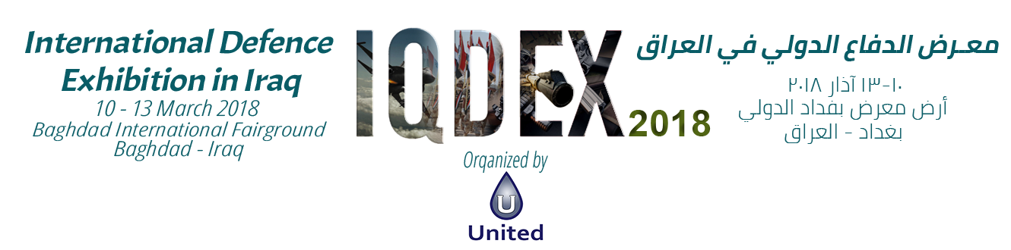

EXHIBITION SPACE CONTRACT STAND #:
EXHIBITOR DETAILS

Company Details
Company Name:

Address:

City: State:
Country:
Telephone:
Postcode/Zipcode:
Website:
Fax:

Main Point of Contact
Contact Name: Direct Dial:

Position: Mobile:

E-mail:

EXHIBIT SPACE OPTIONS & PRICES
Please tick all items that are applicable to you and complete the blank areas.
A

PLAN
INTERNAL AREA (Minimum 18m²) |  | DIMENSIONS | TOTAL SPACE | TOTAL PRICE
Equipped Area ($625/m²) | m x m |  | m2 | $
Not Equipped Area ($550/m²) | m x m |  | m2 | $

Please select one of the below options:
Inline (open to 1 aisle)  %2 + on space total | Corner (open to 2 aisles)  %4+ on space total | Peninsula (open to 3 aisles)  %6 + on space total | Island (open 4 aisles)  %6 + on space total
Amount: $ Amount: $ Amount: $ Amount: $

Note: 15% additional fees will be applied on special design that exceed 3 meters’ height.
TOTAL PAYMENT | $
To be fully received by 5th December 2017 | $

PLAN B

EXTERNAL AREA (Minimum 50m2) | DIMENSIONS | TOTAL SPACE | TOTAL PRICE
Outdoor Space ($350/m2) | m x m | m2 | $

The below percentage will be added to the total price:
TOTAL PAYMENT | $
To be received by 5th December 2017 | $
%4+ on space total
Amount:

PLAN C

For the companies who wish to book internal and external areas:
Plan A Total Payment
Plan B Total Payment
GRAND TOTAL (A + B)

PAYMENT DETAILS

Payment Terms
- Total amount due is payable to UNITED on receipt of our invoice by Dec 5th 2017.
- If the payment was delayed more than one month from the Exhibition date, then delay charges will apply, 4% per one-month delay.

Invoice Details (If different from company details) and Payment Method

Will be provided after signing the contract.

SIGNATURES
Sura H. Mahmood  UNITED  Event Director  Date: | By signing the present application, we formally agree to abide by the terms and conditions overleaf.  This application must be signed by a person duly authorized.  For and on behalf of the exhibiting company  Company Name:
Signature: Position in company:
Date :
Signature and stamp:

LEGAL TERMS

1. ADVERTISING MATTER
The Exhibitor may distribute, only within the confines of its stand, hand bills or other printed advertising matter with respect to its exhibit. The Organizer reserves the right to prohibit the distribution of any advertising material for any reason whatsoever.

2. ALLOCATION
Exhibit space will be allocated according to the date on which this Exhibit Space Contract of the Exhibitor is received and in any case at the full discretion of the Organizer. The Organizer reserves the right in the interest of optimum traffic control and exhibit exposure, to relocate the exhibit or display of the Exhibitor (the exhibit) which may be affected by a change in the floor plan. Such a change would not be made unless deemed necessary by the Organizer. The Organizer agrees to advise the Exhibitor if such a change is necessary. The Organizer’s determination with respect to allocation of exhibit space is to be binding on the Exhibitor. The full contract price shall at all times be payable even if the Exhibitor eventually does not utilize all the exhibit space allocated to him. In the event the Exhibitor’s choice of exhibit space(s) is not available, the Organizer will, where possible, allocate other space. If desired, the Exhibitor may provide the Organizer with a list of competitors whose exhibits (if any) should not be near that of the Exhibitor. The Organizer will, where practicable, accommodate such requests.

3. CANCELLATION
Except as otherwise provided herein, no refund will be made of any money paid to the Organizer in the event of the Exhibitor deciding not to participate and/or decreasing his participation in the Exhibition or if the Organizer terminates this Agreement for a material breach of this Agreement by the Exhibitor. If the Exhibitor decides to cancel participation or decrease the space on or before 20 November 2017, the Exhibitor is liable to pay 75% of the total area cost. If the Exhibitor decides to cancel or decrease his participation after 20 November 2017, the Exhibitor is liable to pay 100% of the total area cost.

4. EXHIBIT CLEANING
The Exhibitors must make arrangements for its exhibits to be kept presentable, clean and free from accumulated rubbish to the satisfaction of the Organizer. All material for disposal as waste must be deposited in the areas designated by the Organizer.

5. LEGALLY BINDING
This Agreement shall enter into force and be deemed to take effect as a legally binding agreement immediately on signature.

6. PROHIBITED EXHIBITS
Unless approved in writing by the Organizer, strictly no live military equipment, including but not limited to such items as munitions, aircraft armament, small arms ammunition and explosives, weapon systems tactical missiles, rockets, etc., shall be brought onto the Exhibition premises. Other kinds of exhibits may be prohibited by the Organizer.

7. PUBLIC SAFETY INSURANCE AND EXHIBITION LIABILITIES
The Organizer recommends that all exhibitors provide their own insurance coverage. In case of any accidents, the organizer will not be responsible for any damages.

8. SAFETY, FIRE, HEALTH AND OTHER LAWS
All fire, safety, health and other laws, rules and regulations imposed by local authorities and agencies or the lessor of the premises where the Exhibition is held must be strictly observed by the Exhibitor. Aisles and fire exits shall not be blocked by exhibits. Decoration of the exhibits shall only be carried out in such manner approved by the Organizer. No storage behind exhibits is provided or permitted.

9. SOUND LEVEL
Mechanical or Electrical devices which produce sound must be operated so as not to prove disturbing to other Exhibitors. The Organizer reserves the right to determine the acceptable sound level in all such instances and to require the removal of any such devices.

10. TERMINATION
The Organizer may terminate this Agreement without liability to Exhibitor immediately on giving notice to the Exhibitor if: (i) the Exhibitor commits a material breach of this Agreement; or (ii) the Exhibitor suspends, or threatens to suspend, payment of its debts, is unable to pay its debts as they fall due or admits inability to pay its debts. Failure by the Exhibitor to pay any payment due to the Organizer under this Agreement by the due date for payment shall constitute a material breach. Subject to the foregoing, in the event that the premises.

