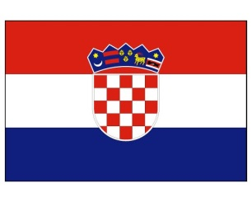
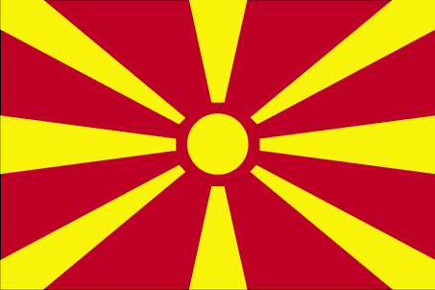

Vacancy announcement: RTA Language Assistant (EU funded project)

Deadline for application: 14 May 2021

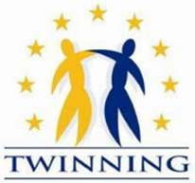

The Annual Action Programme for the Republic of North Macedonia for the year 2018
IPA Twinning Project

"Support to the implementation of the modernised data protection legal framework"
(MK 18 IPA JH 01 20)

RTA Language Assistant

The Twinning Project “Support to the implementation of the modernised data protection legal framework” is a joint project between the Republic of North Macedonia, the Republic of Croatia and the Federal Republic of Germany represented by the Personal Data Protection Agency of the Republic of North Macedonia as beneficiary institution and the Personal Data Protection Agency of the Republic of Croatia and the German Foundation for International Legal Cooperation (IRZ) of the Federal Republic of Germany as EU Member States Twinning partners.

The overall objective of the project is to improve the protection of fundamental rights and the national system for personal data protection in North Macedonia in accordance with the standards of the European Union acquis. Specific objective is to improve the performance of the Personal Data Protection Agency (PDPA) for the implementation of the modernized data protection framework through strengthening institutional capacities, legal and regulatory framework and public awareness on data protection.

The project is seeking a Language Assistant to the Resident Twinning Adviser (RTA Language Assistant) for the period of 15 months, starting on 1 June 2021 until 31 August 2022. The RTA Language Assistant will be employed full time and stationed in Skopje. The RTA Language Assistant may not have or recently (past 6 months) have had any contractual relation with the beneficiary administration of the Beneficiary Country.

Main tasks will include providing daily interpretation and translation of project documentation as well as administrative and organisational support to the Resident Twinning Advisor (RTA) and the short-term experts throughout the Twinning project implementation.

Profile and mandatory requirements:
- University degree
- Excellent command of Macedonian and English both written and spoken
- Experience in translation of documents and interpretation from Macedonian to English and vice versa
- Excellent abilities in drafting documents
- Excellent command of MS Word, Excel, PowerPoint and very good internet skills as well as skills in using social media
- Strong interpersonal and communication skills in an international setting
- Strong organisational skills and ability to work autonomously as well as in a team, having initiative and flexibility

The following skills will be considered as an asset for the RTA Language Assistant:
- Experience in EU funded projects, especially as RTA Language Assistant in a former Twinning project
- Knowledge of the system of North Macedonia in the area of the project
- Experience of working in an international environment

Tasks:
- Translation of project documentation and relevant written material from English into Macedonian and vice versa, as well as providing simultaneous interpretation to the RTA and the project team
- Interpretation during missions, meetings, seminars, trainings, conferences, workshops, and other project events, as well as during other oral conversations from English to Macedonian and vice versa
- Translation of documents, regulations, training materials, information materials and other written material from English into Macedonian and vice versa
- Writing and editing minutes of the meetings, workshops, study visits, etc. and writing information about the project for general public or targeted stakeholders
- If determined necessary, accompanying, interpreting and assisting the beneficiary country participants during study visits to Croatia and Germany
- Day-to-day administrative support to the RTA in overall project management, correspondence, arranging meetings, etc.
- Support to the RTA in various technical tasks such as organisation of the short term experts’ missions, assignments, trainings, conferences and meetings in the Republic of North Macedonia as well as of other project experts
- Close cooperation with the RTA Assistant and if determined necessary, providing office management support and support in project related activities
- Support in the compilation of documents for project documentation, presentations and reporting

Expected start and end of assignment: from 01 June 2021 to 31 August 2022.

Contract type: fixed term service contract.

In case of interest, please send your motivation letter and CV in English in Europass format to the following email addresses sanja.silaj-zeman@azop.hr and twinning@safu.hr with reference to the position RTA Language Assistant by 14 May 2021 at 23:59h local time.

Only shortlisted candidates will be invited for an interview. Interviews are expected to take place remotely (online) in the second half of May 2021.

The selected person will be a self-employed independent consultant under a Service Contract and will undertake full responsibility for the payment of all taxes and obligations deriving from the legislation in force in North Macedonia, including for those related to medical and social insurance. The RTA Language Assistant will carry his/her duties and tasks on the base of contract concluded with the Croatian Central Finance and Contracting Agency.

