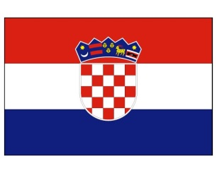
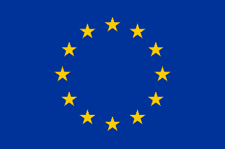

Vacancy announcement: RTA Assistant (EU funded project)

Deadline for application: 14 May 2021

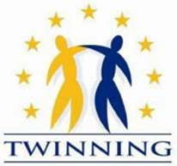

The Annual Action Programme for the Republic of North Macedonia for the year 2018
IPA Twinning Project

"Support to the implementation of the modernised data protection legal framework"
(MK 18 IPA JH 01 20)

RTA Assistant

The Twinning Project “Support to the implementation of the modernised data protection legal framework” is a joint project between the Republic of North Macedonia, the Republic of Croatia and the Federal Republic of Germany represented by the Personal Data Protection Agency of the Republic of North Macedonia as beneficiary institution and the Personal Data Protection Agency of the Republic of Croatia and the German Foundation for International Legal Cooperation (IRZ) of the Federal Republic of Germany as EU Member States Twinning partners.

The overall objective of the project is to improve the protection of fundamental rights and the national system for personal data protection in North Macedonia in accordance with the standards of the European Union acquis. Specific objective is to improve the performance of the Personal Data Protection Agency (PDPA) for the implementation of the modernized data protection framework through strengthening institutional capacities, legal and regulatory framework and public awareness on data protection.

The project is seeking an Assistant to the Resident Twinning Adviser (RTA Assistant) for the period of 15 months, starting on 1 June 2021 until 31 August 2022. The RTA Assistant will be employed full time and stationed in Skopje. The RTA Assistant may not have or recently (past 6 months) have had any contractual relation with the beneficiary administration of the Beneficiary Country.

Main tasks will include providing daily analytical, administrative, technical and project management support to the Resident Twinning Advisor (RTA) as well as to the short-term foreign experts in implementing their activities of the Twinning project.

Profile and mandatory requirements:
- University degree
- Excellent command of Macedonian and English both written and spoken
- Computer literacy (e.g. Word, Excel, PowerPoint, Internet)
- Strong project management and organisational skills: ability to plan workloads and timetables, monitor progress, achieve targets, meet deadlines, prioritise activities, attention to detail, persistence and flexibility
- Proficiency in administrative documents / report drafting in English
- Understanding of financial management
- Skills and practical knowledge in using social networks
- Strong interpersonal and communication skills as well as great deal of diplomacy and tact in an international setting
- Ability to work autonomously as well as in a team, having initiative and flexibility

The following skills will be considered as an asset for RTA assistant:
- Experience in EU funded projects, especially as RTA Assistant in a former Twinning project
- Knowledge of the system of North Macedonia in the area of the project
- Experience of working in an international environment

Tasks:
- Support to the Resident Twinning Advisor (RTA) in overall office management, execution of general administrative tasks necessary for the implementation of the project, project management, analysis, reporting, record keeping and monitoring of the progress of project activities
- Day-to-day assistance to the RTA
- Support to the RTA in the preparation and organisation of the different activities from the technical point of view
- Developing and maintaining close contacts and working relationships with beneficiary institution, counterparts, EUD and other relevant beneficiary country actors as well as Croatian and German partner institutions
- Organizing the exchange of information between project participants
- Organisation of the short-term experts’ assignments and meetings as well as project related missions of the Project Leaders and other Member State partner staff
- Providing necessary support in the organisation of meetings, seminars and workshops in cooperation with the partners, including quarterly Steering Committee Meetings, preparing agenda for the meetings (including preparation of invitation letters and documents, etc.)
- Assistance in writing and editing of rolling work plans, project reports and any other relevant project documents in English and Macedonian; budget accounting
- Writing and editing minutes of the meetings
- Organizing visibility events, assistance in the preparation of the necessary documents (invitation, agenda) and promotional materials
- Acting as an interpreter for the purpose of the project (e.g. meetings, workshops, visibility events) and providing translation and interpretation services for the RTA and for short-term experts during their missions
- Translating and editing of all documents relating to project activities (legislation, mission reports, correspondence, presentations by short-term experts, etc.) from English to Macedonian and vice versa
- Processing of telephone correspondence and general correspondence
- Helping in organization of study visits in Croatia and Germany
- If determined necessary, accompanying, interpreting and assisting the beneficiary country participants during study visits to Croatia and Germany
- Assistance to the short-term experts during their missions, helping with all the office work, preparation of the project documentation (work orders/terms of reference)
- Facilitate the exchanges between the RTA and other members of the Twinning project team and different stakeholders
- Organization of trips, reservation of accommodation, etc.
- Other tasks as required
- Close cooperation with the RTA Language Assistant

Expected start and end of assignment: from 01 June 2021 to 31 August 2022.

Contract type: fixed term service contract.

In case of interest, please send your motivation letter and CV in English in Europass format to the following e-mail addresses sanja.silaj-zeman@azop.hr and twinning@safu.hr with reference to the position RTA Assistant by 14 May 2021 at 23:59h local time.

Only shortlisted candidates will be invited for an interview. Interviews are expected to take place remotely (online) in the second half of May 2021.

The selected person will be a self-employed independent consultant under a Service Contract and will undertake full responsibility for the payment of all taxes and obligations deriving from the legislation in force in North Macedonia, including for those related to medical and social insurance. The RTA Assistant will carry his/her duties and tasks on the base of contract concluded with the Croatian Central Finance and Contracting Agency.

