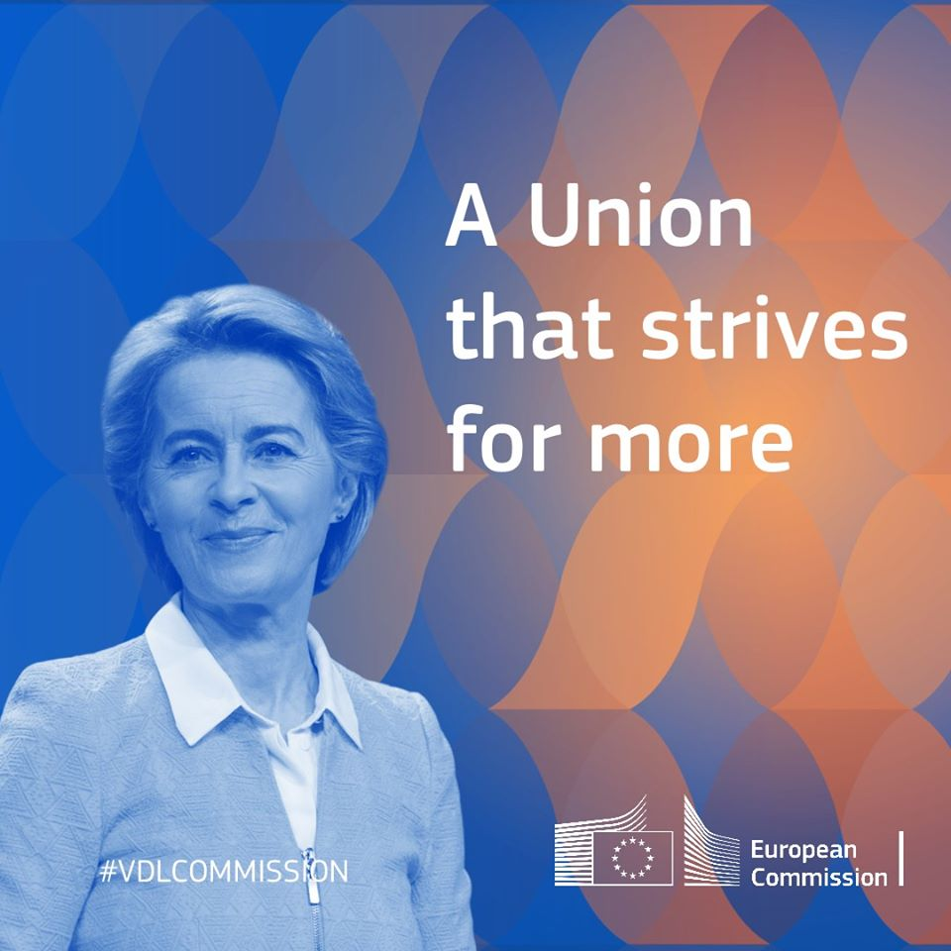

Citizens' Dialogue
with Vice-President Dubravka Šuica: Demography and democracy

Sofia (Bulgaria) on 12 October 2021

TABLE OF CONTENTS

1. Scene Setter and Step-by-step programme
1.1 Location and features of the hosting venue
1.2 Format and audience
1.3 Stage partner
1.4 Moderator
1.5 On-site votes / survey / word cloud
1.6 Media information (incl. social media)
1.7 Security

2. Hot issues in Bulgaria

3. Political and economic situation in Bulgaria
4. Public opinion in Bulgaria
5. European Commission priorities for 2019-2024

Annexes
Annex 1 CVs
Annex 2 floor plan and set-up of the venue

SCENE SETTER AND STEP BY STEP PROGRAMME

President Ursula von der Leyen, in the mission letters sent to all Members of the College announced:

I want to strengthen the links between people and the institutions that serve them, to narrow the gap between expectation and reality and to communicate about what Europe is doing. We must engage with all Europeans, not just those who live in the capitals or are knowledgeable about the European Union. I will expect you to visit every Member State within the first half of our mandate at the latest. You should meet regularly with national parliaments and take part in Citizens’ Dialogues across our Union, notably as part of the Conference on the Future of Europe.

1.1. Location and features of the hosting venue
The Citizens’ Dialogue will take place in the House of Europe, 124 Georgi S. Rakovski Str, Sofia, Bulgaria. It is scheduled from 11:00 to 13:00 (BG time/EEST) for a total of up to 120 minutes.

1.2. Format and audience

Title:

Citizens' Dialogue with Vice-President Dubravka Šuica of the European Commission: Demography and democracy

The event is organized by the Ministry of Foreign Affairs of Bulgaria, the Ministry of Foreign and European Affairs of Croatia, Embassy of Croatia in Bulgaria, European Commission Representation in Bulgaria and PanEuropa Bulgaria within the framework of the Conference on the Future of Europe.

Audience could watch streaming online and send questions through sli.do. They will be moderated and used for the discussion.

Depending on applicable COVID-19 measures, we envisage up to 15-20 pre-selected guests at the House of Europe from representative youth organizations such as National Youth Forum. Guests will be invited also by Bulgarian Ministry of Foreign Affairs and the Embassy of the Republic of Croatia in Bulgaria.

Working language of the event will be English with interpretation in Croatian and Bulgarian.
1.3 Stage partner
N/A

1.4. Moderator

Moderator will be TV journalist Dobrina Cheshmedjieva. (CV attached in Annex 1).
1.5 On-site votes / survey / word cloud (if applicable)
The audience will participate in vote(s) through sli.do.
1.6 Media information (incl. social media)
Streaming in Bulgarian: on the Facebook page of the EC Representation in Bulgaria: https://www.facebook.com/ECinBulgaria/ and the FB channel of the Ministry of Foreign Affairs of the Republic of Bulgaria: https://www.facebook.com/MFABulgaria
Streaming in Croatian: on the Facebook page of the EC Representation in Croatia: https://www.facebook.com/europska.komisija.zagreb/ and the Facebook page of the Ministry of Foreign Affairs of the Republic of Croatia: https://www.facebook.com/MVEP.hr
Streaming in English on the webpage of the EC Representation in Bulgaria.
Code for streaming will be shared on the website of the EC Representation in Bulgaria (https://ec.europa.eu/bulgaria/) and the pages of the both ministries so that any interested media could use it.
1.7 Security
Participants are required to register before the event and have to provide an ID document upon arrival. Before entering the venue participants will have to pass through metal detectors and their bags will be checked by security personnel. It is not possible to bring larger bags/suitcases. Participants would be subject to applicable COVID-19 checks, as well (temperature checks, for example).

2. Step-by-step program

Time: 11:00 – 13:00 (preceded by preparatory meeting at 10:30)
Venue: House of Europe conference hall
Language: English

The Dialogue will mainly focus on: demography, brain circulation, CoFE, youth participation
11:00 – 11:05 | Technical info on the Dialogue, presented by the moderator
11:05 – 11:15 | Opening remarks by:  H.E. Mr. Gordan Grlić Radman, Minister of Foreign and European Affairs of the Republic of Croatia  H.E. Mr. Svetlan Stoev, Minister of Foreign Affairs of the Republic of Bulgaria
11:15 – 11:30 | Video on the Atlas of Demography.:  Dubravka Šuica, Vice-President of the European Commission for Democracy and Demography  Language: English
11:30 – 11:50 | The cases of Bulgaria and the case of Croatia –presentations from each country  Željka Josić, State Secretary for Demography and Youth of the Republic of Croatia  Georgi Bardarov, Vice-Dean of Geology and Geography department of Sofia University
11:50– 12:20 | Q & A discussion on demography, brain circulation  What is most important for you when choosing a place to live?  - Employment opportunities  - Cost of living  - Connectivity (transport, internet, etc.)  - Safety / Rule of law  - Proximity to family and friends  - Climate  - Culture  - School & Education system  - Healthcare  - Other
12:20– 12:50 | Q & A discussion on CoFE and youth participation in democratic life, starting with a slido poll:  Do you think your voice is heard enough in the EU?  - Yes  - No
12:50 – 13:00 | Final remarks by VP and closing of the event

2. HOT TOPICS in BULGARIA
TO BE UPDATED BEFORE THE EVENT

3. POLITICAL AND ECONOMIC SITUATION in BULGARIA (Background)
TO BE UPDATED BEFORE THE EVENT

4. PUBLIC OPINION in BULGARIA
Public perception of Europe in Bulgaria is positive – the EU conjures up a total 'positive' image in 59% of Bulgarians – well above the EU-average of 46%. There is a 6% increase in the positive marks in comparison to the previous EB (93). Bulgaria is one of the three countries in which the EU has the most positive image, together with Portugal (76%) and Latvia (57).
Bulgarians are positive about EU membership and demonstrate trust in the EU and its institutions. The share of Bulgarian citizens who trust the EU has increased slightly since the summer of 2020, and accounts to 53% in February 2021.
The main concerns in Bulgaria according to the latest Eurobarometer (EB 94, February 2021) are the healthcare situation (47%), the economic situation (33%), rising prices/inflation/cost of living (33%) and unemployment (30%). Regarding the economic situation in the country, only 22% are optimistic that it will get better in the next twelve months. On the other hand, 27% of Bulgarians think that the economic situation in the EU will get better in the next year, similar to the EU 27 average (26%)
European Green Deal (EGD)
According to 51% of Bulgarians, the fight against plastic waste and leading on the issue of single-use of plastic should be given top priority in the new EGD. The second-highest priority for Bulgarians (41%) and for Europeans in general (39%) is support for European farmers. 62% of Bulgarians are supportive of a common energy policy among the EU Member States.
COVID-19
32% of Bulgarians think the country’s economy will recover before 2023 from the adverse effects of the Coronavirus outbreak, slightly more optimistic than the EU 27 average (28%). However, the share of Bulgarian citizens (12%), who think the country’s economy will never recover, is bigger than the EU average (8%).
The latest EB 94 results indicate that a significant part of Bulgarians (42%) define the confinement measures as difficult to cope with.
COVID-19 vaccines
The share of Bulgarian citizens who believe that the EU has a key role in providing access to vaccines is significant (87%) and higher than at the European average (69%). About two thirds of Bulgarians (62%) doubt the safety of coronavirus vaccines due to the rapid pace of their development.

Shortly after the start of the immunization campaign, Bulgarians declared a significantly lower willingness to be vaccinated against coronavirus than EU citizens. The share of Bulgarian citizens (19%) who would like to be vaccinated as soon as possible (or have already done so) is more than twice lower than at EU27 level (45%). High level of skepticism about the safety of vaccines is probably one of the reasons for the relatively large percentage of Bulgarians who say they are reluctant to get vaccinated at all (22%).
More optimistic on the future of the EU
Bulgarians are slightly less optimistic (59%) about the future of the European Union than the average European (60%).
EU is seen as leverage in many areas, in particular the judicial reform and the fight against organised crime and corruption. 70% of the Bulgarians believe EU should have a role in tackling the corruption in the country and 57% see EU as having a positive impact on the judicial system (Flash Eurobarometer 445 on CVM published in January 2017).

5. EUROPEAN COMMISSION PRIORITIES FOR 2019-2024

A European Green Deal
Becoming the world’s first climate-neutral continent by 2050 is the greatest challenge and opportunity of our times. To achieve this, the European Commission presented the European Green Deal, the most ambitious package of measures that should enable European citizens and businesses to benefit from sustainable green transition. Measures accompanied with an initial roadmap of key policies range from ambitiously cutting emissions, to investing in cutting-edge research and innovation, to preserving Europe’s natural environment. Supported by investments in green technologies, sustainable solutions and new businesses, the Green Deal can be a new EU growth strategy. Involvement and commitment of the public and of all stakeholders is crucial to its success.
Above all, the European Green Deal sets a path for a transition that is just and socially fair. It is designed in such a way as to leave no individual or region behind in the great transformation ahead.

An economy that works for people
Individuals and businesses in the EU can only thrive if the economy works for them. The EU’s unique social market economy allows economies to grow and to reduce poverty and inequality. With Europe on a stable footing, the economy can fully respond to the needs of the EU’s citizens.
For that, it is essential to strengthen small and medium-sized enterprises, the backbone of the EU’s economy. It is also essential to complete the Capital Markets Union and to deepen the Economic and Monetary Union.ks for people

A Europe fit for the digital age
Digital technologies are connecting the world in unforeseen ways, at unprecedented speed. Europe already sets the standards in telecoms and data protection, for instance. However, it falls behind in other areas of the digital economy. Investments in blockchain, high-performance computing, quantum computing, algorithms and new tools for secure data sharing and usage are the starting point on the path to innovation.
Data and Artificial Intelligence (AI) technologies can help develop smart solutions for many societal challenges, from health to farming, from security to manufacturing. Bringing down barriers to learning and improving access to quality education is key to paving the way for a new European Education Area.

Promoting our European way of life
A Europe that protects must also stand up for justice and for the EU’s core values.
Threats to the rule of law challenge the legal, political and economic basis of our Union. The rule of law is central to President von der Leyen’s vision for a Union of equality, tolerance and social fairness.
The Commission will launch a comprehensive European Rule of Law Mechanism under which it is to report every year, objectively, on the state–of-play on the rule of law across the Union.
Strong borders, modernisation of the EU’s asylum system and cooperation with partner countries are important to achieve a fresh start on migration.

A stronger Europe in the world
The European Commission champions multilateralism and a rules-based global order through a more active role and stronger voice for the EU in the world.
A strong, open and fair trade agenda, making Europe an attractive place for business, is key to strengthening the EU’s role as a global leader while ensuring the highest standards of climate, environmental and labour protection. European leadership also means working shoulder-to-shoulder with neighbouring countries and partners, introducing a comprehensive strategy on Africa and reaffirming the European perspective of the countries of the Western Balkans.
The Commission seeks a coordinated approach to external action - from development aid to the Common Foreign and Security Policy - that secures a stronger and more united voice for Europe in the world.

A new push for European democracy
The record-high turnout in the 2019 European elections shows the vibrancy of the European democracy. Yet, Europeans need a stronger role in the decision-making process and a more active role in setting our priorities. A Conference on the future of Europe will enable them to have their say over what is important for the EU.
In order to protect our democracy from external interference, a joint approach and common standards are necessary to tackle issues such as disinformation and online hate messages.
The Commission will engage in consolidating its partnership with the European Parliament, the voice of the people, by ensuring its involvement at all stages of international negotiations, as well as transparency and integrity throughout the legislative process.

Annex 1

Biography of Dobrina Cheshmedjieva,
Moderator
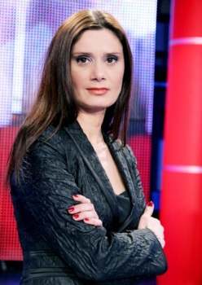
Dobrina Cheshmedjieva is a journalist in Bulgarian National Television. Producer in the News Department and host of weekly political talk show called “Referendum”. The “Referendum” talk show has broadcasted a political debate on topics about the Bulgarian membership in the European Union live from Brussels.
During her almost 20-year career in the Bulgarian National Television, she hosted the Live Studios of all the European Elections that were carried out in Bulgaria.
She has also been a moderator of a number of discussions and public debates, including “Dialogue with the Citizens” – an initiative of the President of the Republic of Bulgaria, Rosen Plevneliev, with the subject the Media in Bulgaria.
Dobrina Cheshmedjieva is author of several documentaries, among them a documentary about the immigrants from Libya to the Italian island of Lampedusa in 2013.
Last years she worked on numerous European Union oriented topics covering the successful use of EU funds in Denmark, Italy, Spain and Estonia.
Ms Cheshmedjieva has interviewed HH Margrethe II of Denmark, José Manuel Barroso, Andrus Ansip, Tarja Halonen, Franco Frattini, Shimon Peres and Mahmoud Abbas. She has also participated in a programme of the European Journalism Centre on the collaboration between the EU and the Middle East. Dobrina Cheshmedjieva has received prizes and awards, including “Journalist of the Year” in 2012.

Annex 2

Examples of venue set-up with and without audience
(all COVID-19 social distancing guidelines will be observed)
