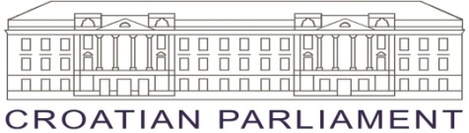
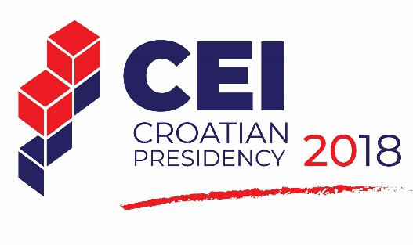

MEETING OF THE PARLIAMENTARY ASSEMBLY
OF THE CEI PARLIAMENTARY DIMENSION
Zagreb, 26 November 2018
Croatian Parliament

FINAL DECLARATION

Recalling the Joint Statement of the Parliamentary Committee held in Zagreb on 14th May 2018;
Focusing on the well-being of local community, economic viability of local community and viability of local culture and environment;
Calling on Member States to minimize tourism related threats to environmental, natural and cultural heritage of a particular place or community;
Having in mind that regional cooperation plays a crucial role in the development of tourism;
Recognizing that numerous sustainable tourism initiatives, particularly in tourism infrastructure, have proved to be financially and socially viable in the long run;
Being aware of the great importance of cooperation between tourism and other sectors, including economy, environment protection and culture;
Recognizing the relevance of the three dimensions of sustainability: social, economic and environmental;
Expressing the need for ensuring continuous financial support aimed towards development of sustainable tourism;
Reminding of the importance of the CEI strategic approach to regional cooperation and supporting those CEI Member States who are on their way to European integration in all areas, including the aspect of the tourism cooperation.

We, the participants of the Central European Initiative – Parliamentary Dimension, Parliamentary Assembly held in Zagreb on 26th November 2018

Encourage the CEI Member States and their public and private sectors to actively engage in developing tourism and supporting local communities in order to advance sustainable, inclusive, accessible, responsible and high-quality tourism;
Invite national parliaments and governments to endeavor in even distribution of tourism benefits through all relevant sectors and throughout all calendar year;
Appeal to the CEI Member States to remove the barriers in order to enable access of local micro and small enterprises to the market;
Appeal to the CEI Member States to remove architectural barriers in order to enable access for people with disabilities and to incentivize the construction of facilities for people with disabilities;
Invite the CEI Member States to stimulate tourism businesses in increasing their linkages to local economy and local producers through their supply chain;
Stress the need to provide opportunities for tourists to support local communities in a meaningful and dignified way;
Underline that the process of planning, decision making, management and future development of tourism should include and engage local community stakeholders;
Emphasize that tourism has to provide opportunities for employment, fair distribution of economic and social benefits at the community level as a whole;
Highlight the importance of local people being direct owners in the tourism related business on the local level;
Acknowledge that tourism has to provide community well-being also through strengthening the quality of life for men and women, for youth and elderly people, including the vulnerable groups;
Affirm that integrated approach to sustainable tourism development within local community has to be based on transparency, mutual respect and shared risk taking;
Confirm that environmental sustainability includes equal sustainability of cultural and natural environments in local communities;
Call upon Member States to continuously monitor the impact of tourism sector on the local community environment in order to minimize the pollution of air, water, land, and the generation of waste by tourism enterprises and visitors and to implement the UNWTO Global Code of Ethics for Tourism;
Urge investors in tourism at all levels to build and operate in an ecologically and environmentally sustainable manner;
Encourage national parliaments to endorse laws aiming at the reuse of abandoned buildings and laws against overbuilding.
Underline that physical integrity, quality of landscapes, both urban and rural should be maintained and enhanced, while physical and visual degradation of the local environment avoided;
Recommend active extensive cross-sectoral cooperation in order to provide balanced use of heritage on local and regional level;
Encourage national parliaments to endorse natural and cultural heritage protection and management laws and practices, which have to be integrated into tourism development policies at local level to ensure protection and conservation of heritage over time;
Appeal to all CEI Member States and their national parliaments to facilitate smooth adoption of the tourism related legislation that will enable launching of the potential future sustainable tourism projects, according to the Sustainable Development Goals and the Paris Declaration;
Support the CEI Plan of Action 2018 - 2020 as a concise and ambitious tool to streamline and focus CEI activities which supports strong links to EU-policies;
Express our full support for the incoming Italian CEI Presidency convinced that all CEI dimensions will further gain in importance and visibility in the course of 2019.

