Dear Sir or Madam,
I greet you on behalf of the MEETING G2 Association, which has been connecting Croatia and the diaspora, businesspeople of Croatian origin from all over the world, through its annual conferences for eight years. Meeting G2 is part of the ONE CROATIA global initiative, which, after the earthquake in Zagreb and Banovina, gathered about 30 Croatian associations from the country and the world, and together we helped collect about 420,000 USD, which we donated to Sisak Hospital, Emergency Services, firefighters, engineers, Children's Home Willow etc.
We have held all previous MEETING G2 conferences in Zagreb, and now we are going outside Zagreb for the first time. In beautiful Banovina, in the city of Sisak! The name of this year's conference is MEETING G2.9 - THE LAND OF RISING OPTIMISM.
More information about previous meetings on the official website: www.meeting-g2.com.
We decided to hold our 9th MEETING G2 conference (from September 28 to 30) in the center of the county, which suffered heavily not only in the Homeland War, but also in the recent earthquakes. The conference will be held in the Bussiness Incubator PISAK, in partnership with the Applied Ceramics company of Mr. Matt Sertić, a returnee from the USA.
We want to bring to Sisak not only entrepreneurs from Banovina and Croatia, but also entrepreneurs of Croatian origin from all over the world, from Australia and Europe to North and South America. At the Conference, we want to present numerous attractive business opportunities for quality investments to all visitors, and our goal is to help create new jobs, production facilities and overall economic growth. We are a group of ordinary small volunteers, but we have done a lot in the last eight years because we all share the same emotions towards our homeland and the same desire - to help the economy and people to live better, richer, more satisfied, and happier...
We believe that Croatia has not only four million inhabitants, but eight, because more than half of us live all over the world. And we have been connecting and networking precisely these wonderful people with innovators, exporters, manufacturers, start-ups from Croatia for eight years... We help them find partners; we want to help you too!
For more information, feel free to contact us via email: info@meeting-g2.com
Tickets are already available at: https://www.entrio.hr/event/mg29-zemlja-izlazeceg-optimizmathe-land-of-the-rising-optimism-14291.
We look forward to cooperation and meeting, for the benefit of all of us and you, but also our common and only homeland! You can watch here the music video for the song "Jedna domovina", which the Zaprešić Boys dedicated to the Croatian diaspora, and the MEETING G2 Association and the ONE CROATIA initiative actively helped make the video: https://youtu.be/oH9gRJI3PrQ.
With respect,
Antun Krešimir Buterin
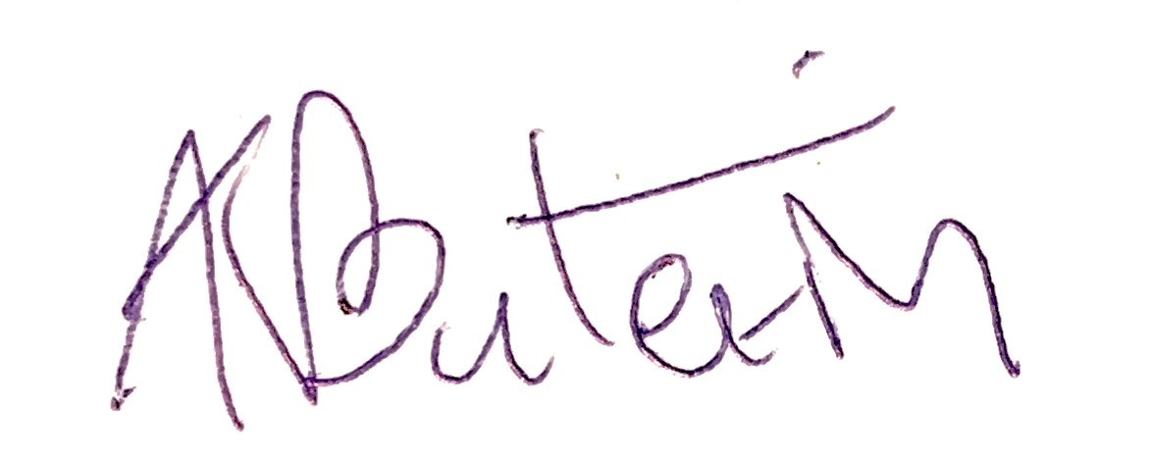
predsjednik Udruge MEETING G2

